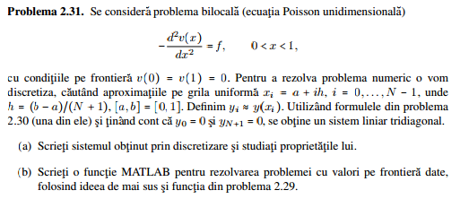

$$f^{''}= \frac{f\left(x+h\right)-2f\left(x\right)+f(x-h)}{h^{2}}+R(h)$$
$x_{i}=x_{0}+ih=0+ih=ih$
$v\left(x_{i}\right)=v_{i}$ $f\left(x_{i}\right)=f_{i}$
$-v^{''}=f v\left(0\right)=v\left(1\right)=0$
$-v^{''}\left(x_{i}\right)=f(x_{i})$
$-v^{''}\left(x_{i}\right)=-{v^{''}}_{i}≈-\frac{v_{i+1}-2v_{i}+v_{i-1}}{h^{2}}=f_{i}$
${-v}_{i-1}+2v_{i}-v_{i+1}= f_{i}$
- pentru $i=1: {-v}_{0}+2v_{1}-v_{2}= f_{1}$
…………………………………………………………………………………….
- pentru $i=n-1: {-v}_{n-2}+2v_{n-1}-v_{n}= f_{n}$

$$\left\{\begin{aligned}2v_{1}-v_{2}=f_{1} \\ -v_{i-1}+2v_{i}-v_{i+1}=f_{i} \\ 2v_{n-1}-v_{n}=f_{n}\end{aligned}\right.$$

A= $\left[\begin{matrix}2 & -1 & 0 & ⋯ & ⋯ & 0 \\ -1 & 2 & -1 & 0 & ⋯ & 0 \\ ⋮ & ⋱ & ⋱ & ⋱ & ⋱ & ⋮ \\ 0 & 0 & ⋯ & -1 & 2 & -1 \\ 0 & 0 & ⋯ & 0 & -1 & 2\end{matrix}\right]$
A$v=f, f=\left[\begin{matrix}f_{1} \\ ⋮ \\ f_{n}\end{matrix}\right]$

